Load Balancers Task
- Configure Classic Load balancer.
User
↓
Classic Load Balancer
↓ ↓
EC2-1 EC2-2
- Configure Classic Load balancer
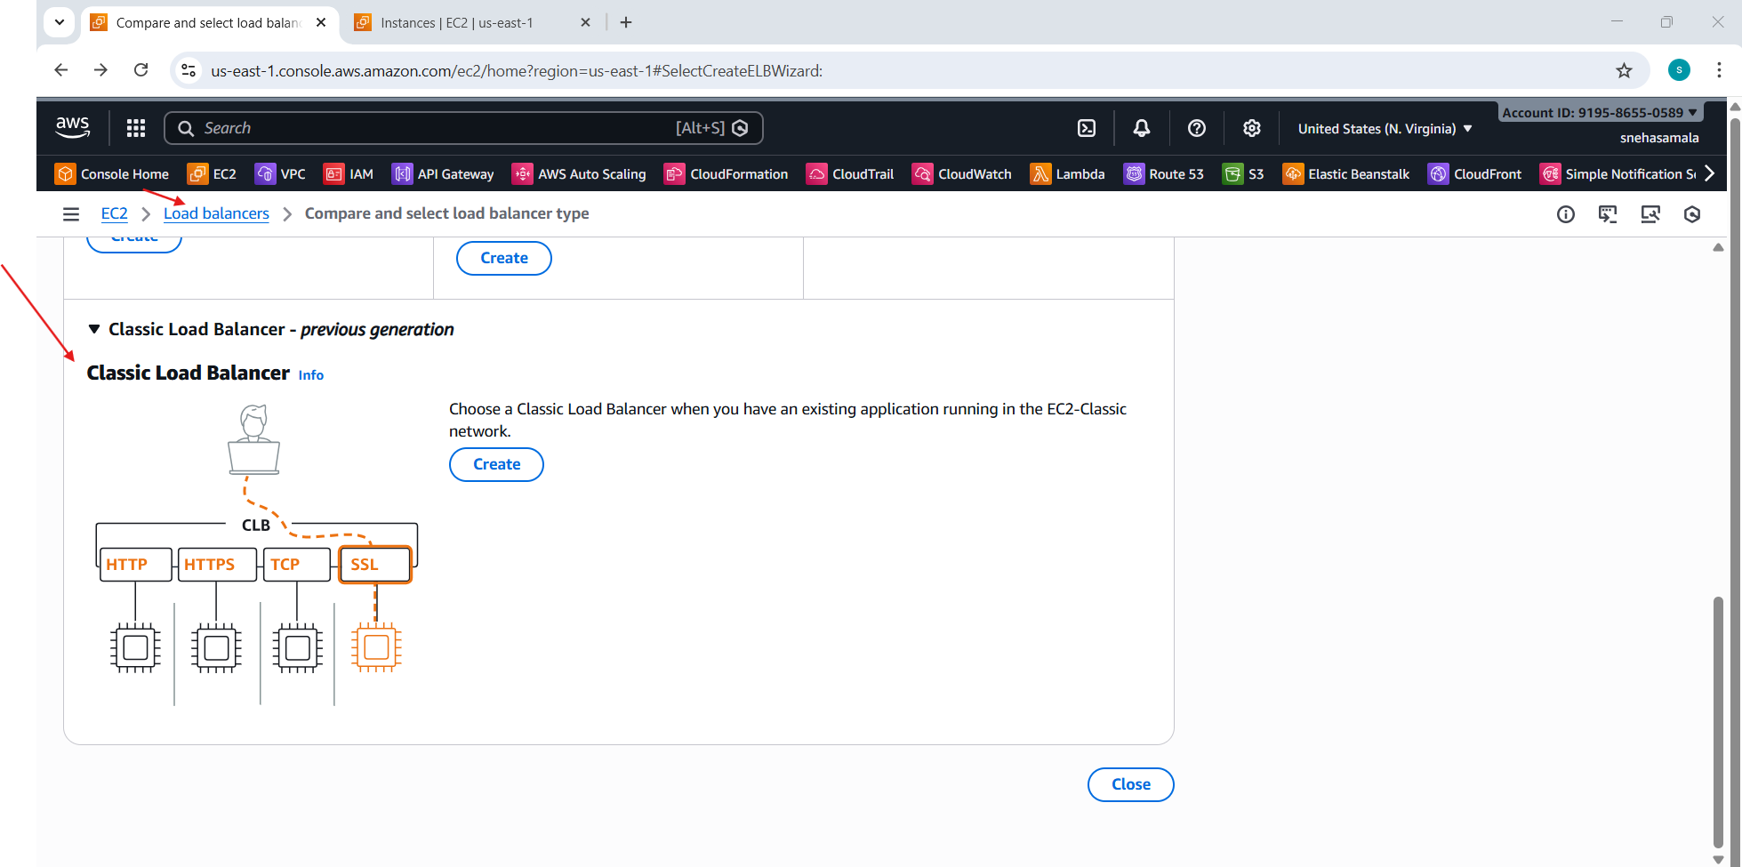
- Name the load balancer
- Example: my-classic-lb
- Choose Scheme:
- Internet-facing (public)
- Internal (private)
- Select VPC
- Choose Availability Zones (at least 2 for HA)
- Create Listeners:
- HTTP → 80
- Attach a Security Group to the CLB
- Allow inbound rules:
HTTP (80) from 0.0.0.0/0

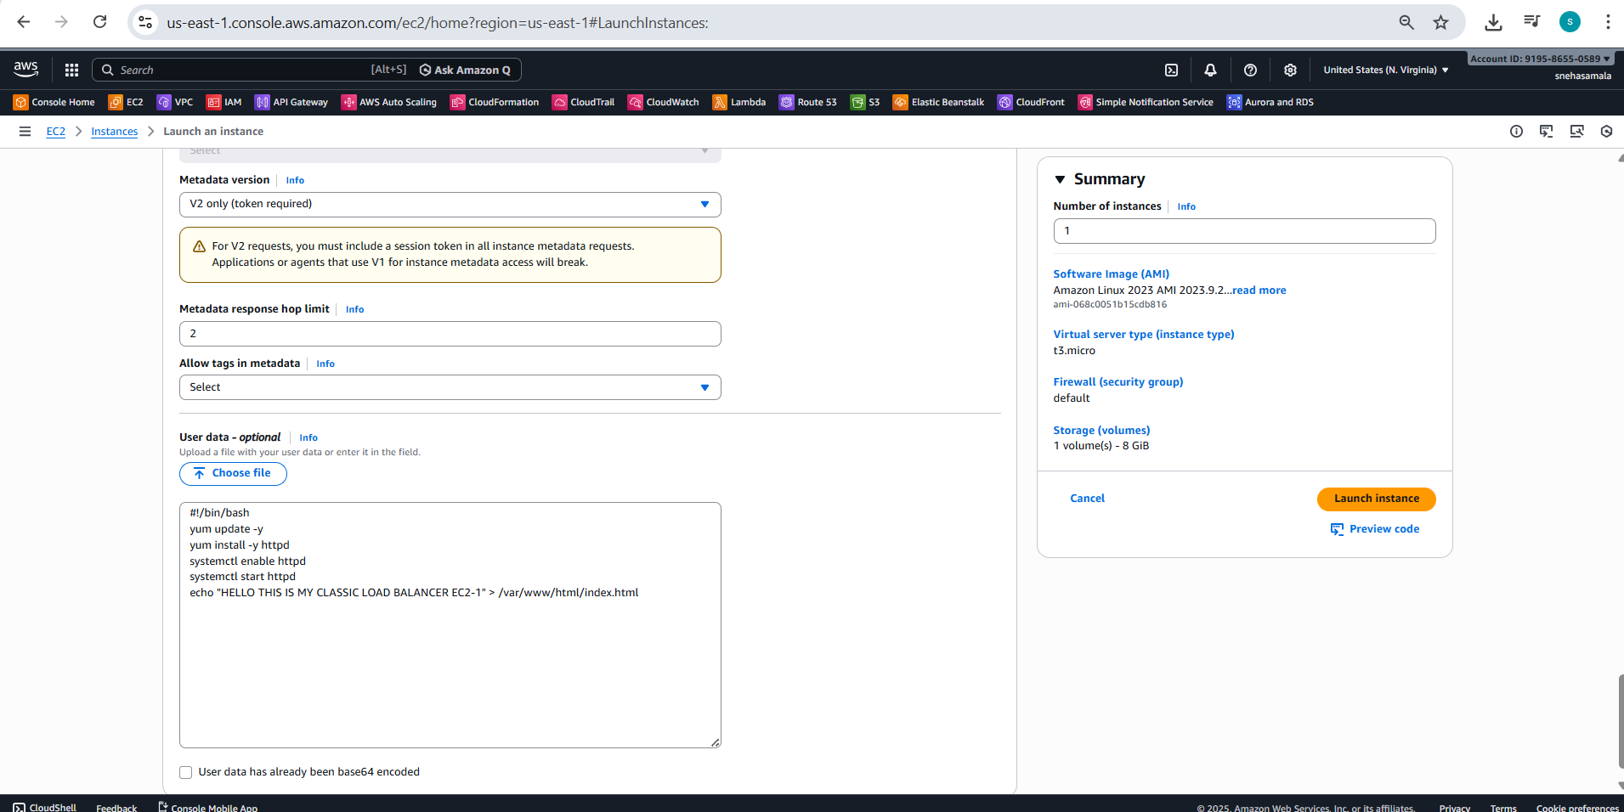
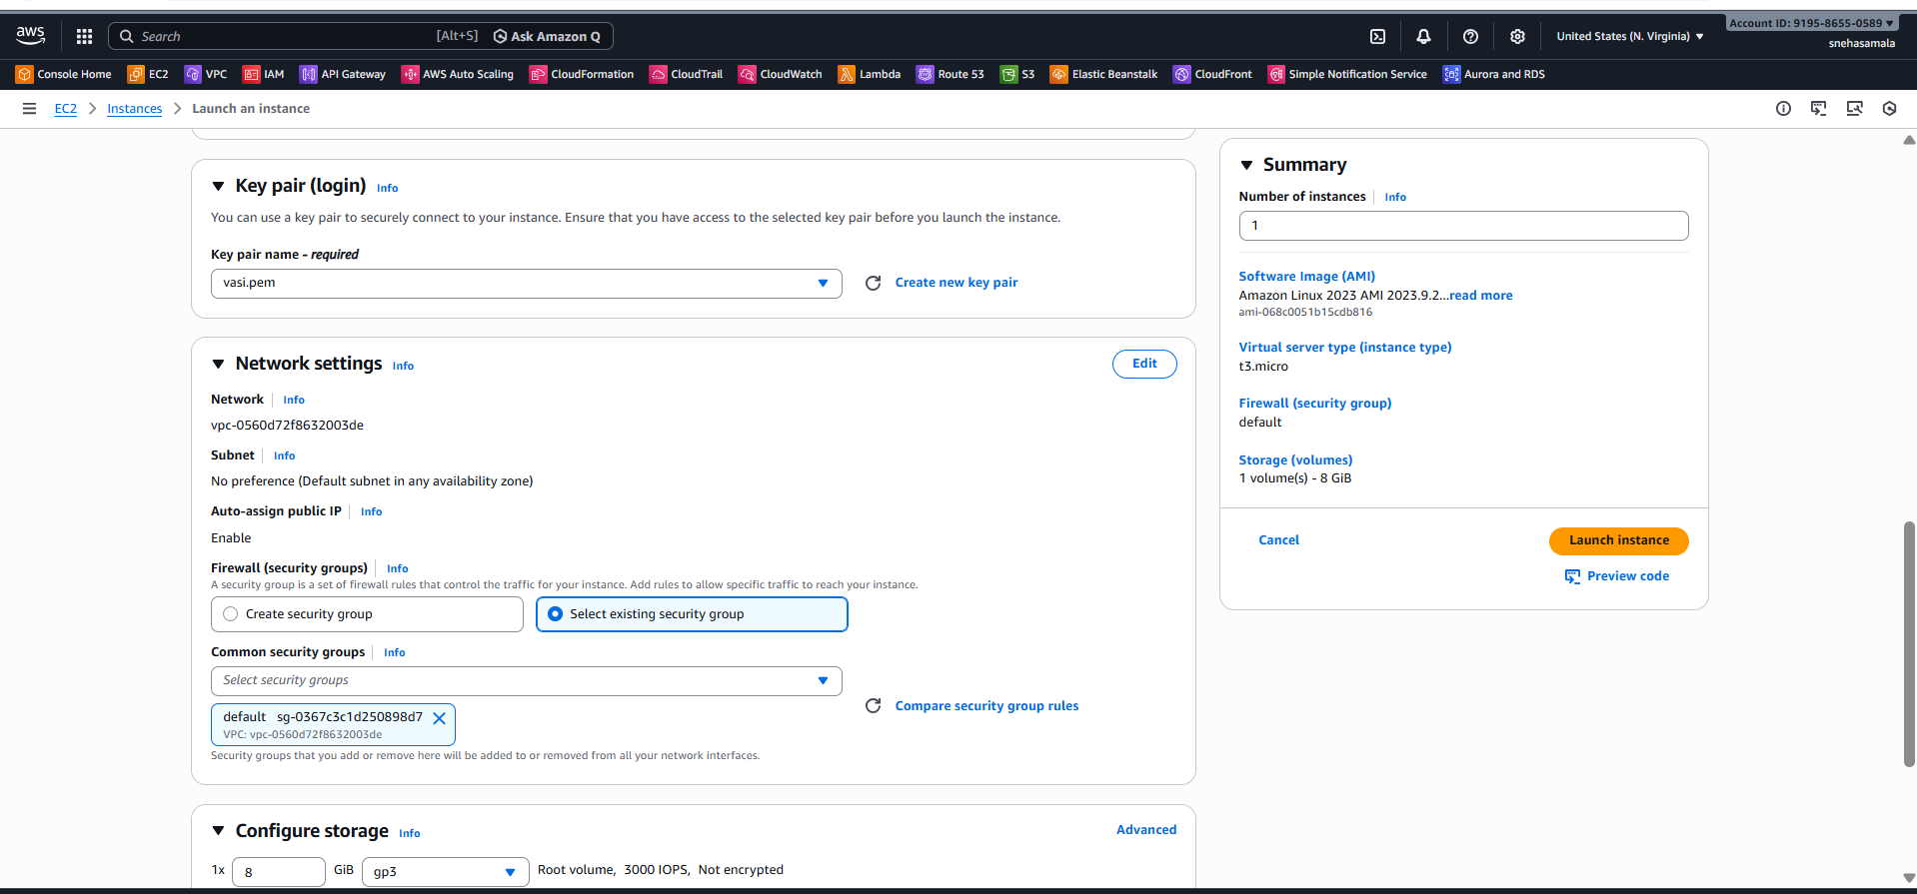

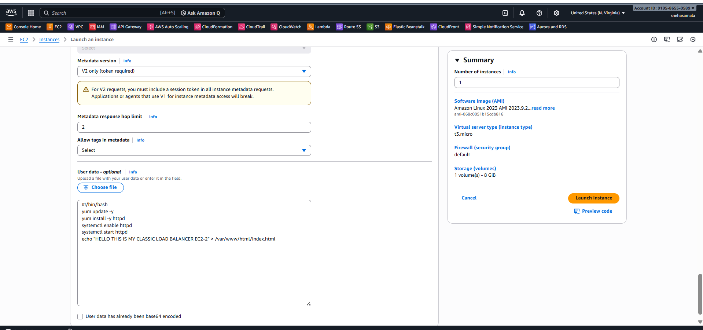
- Click Create Load Balancer
- Classic Load Balancer is now created.
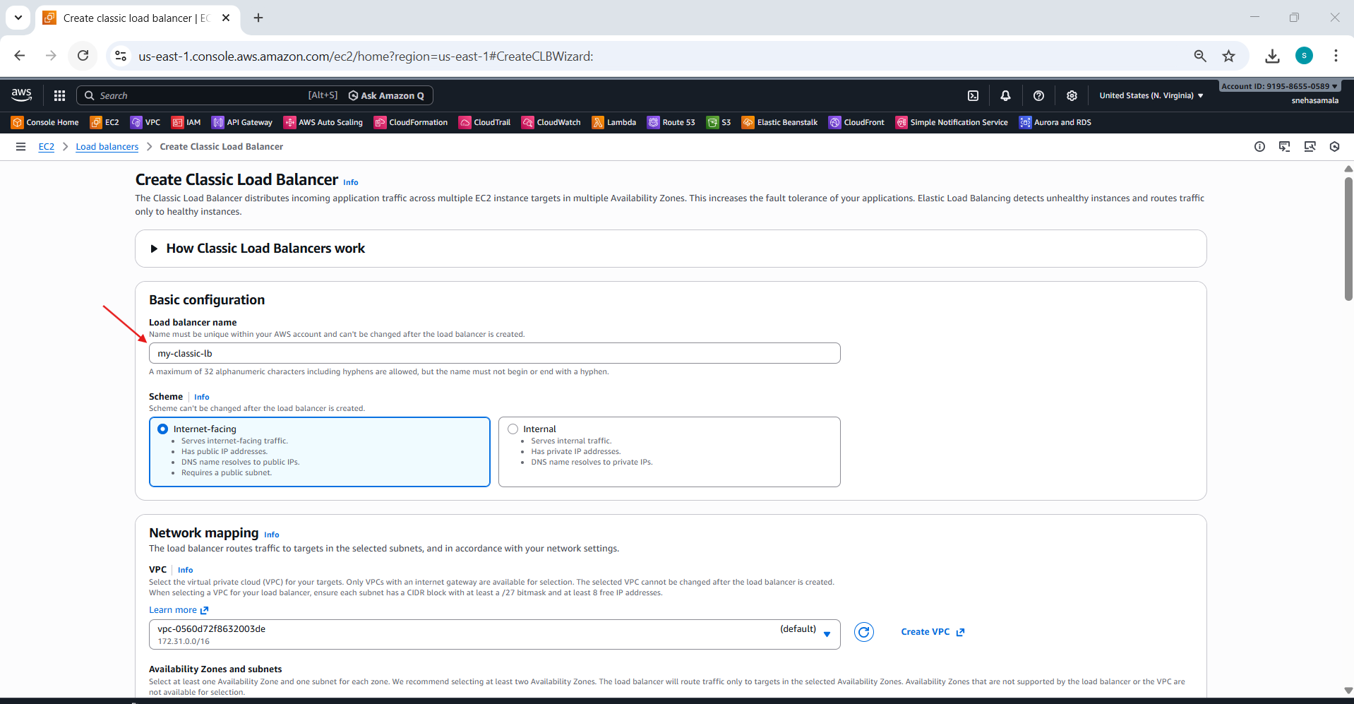
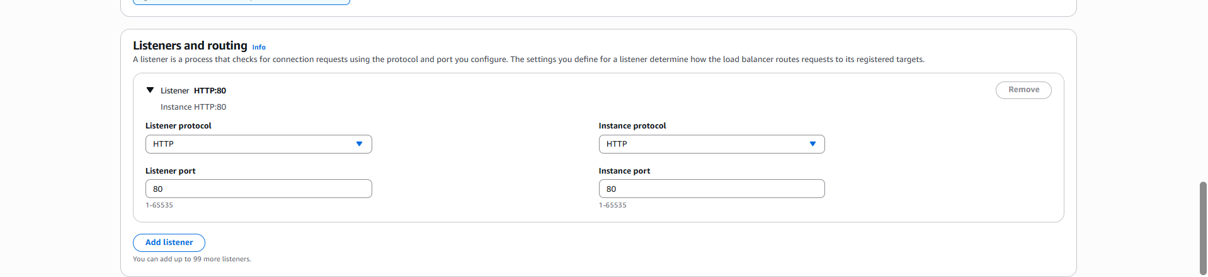
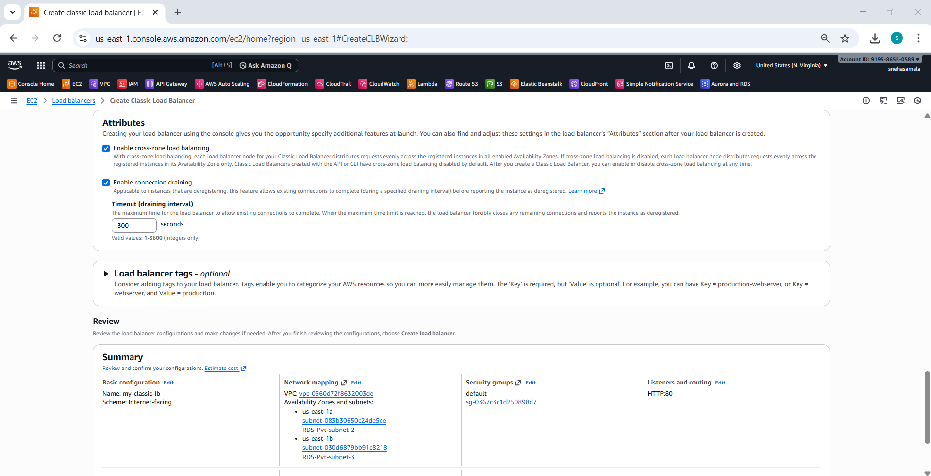

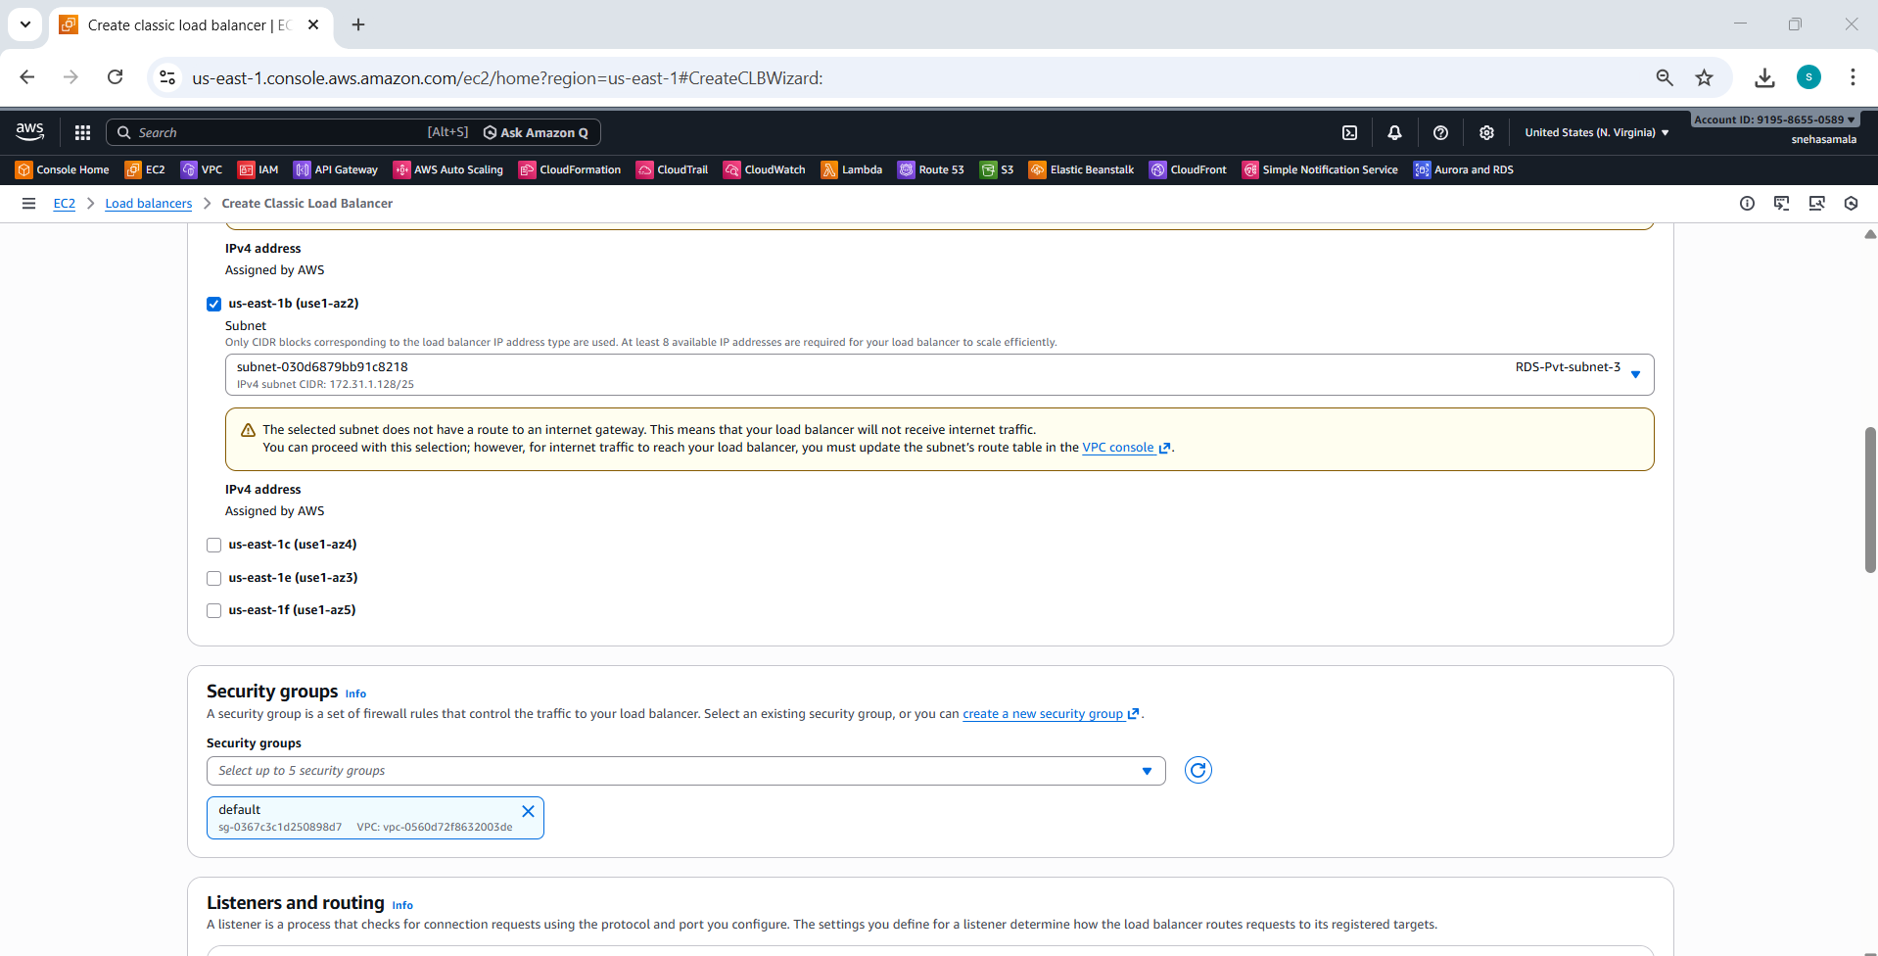
- Test the Classic Load Balancer
- Browse with the DNS
- LOAD EC2 01
- LOAD EC2 02


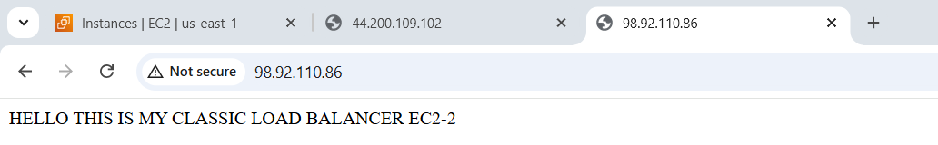
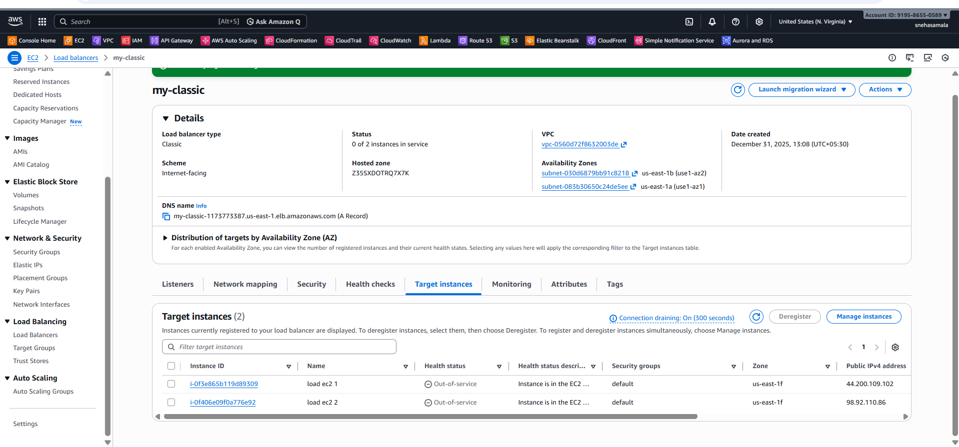

- Configure Application Load balancer.
- Create a Target Group
- A Target Group defines where traffic will be sent.
Steps:
- Go to EC2 → Target Groups → Create target group
- Choose Target type:
- Instance (EC2)

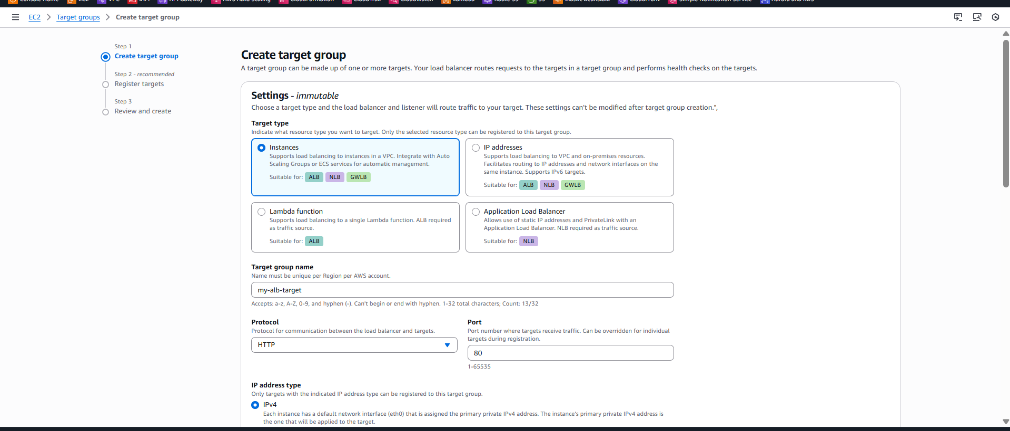
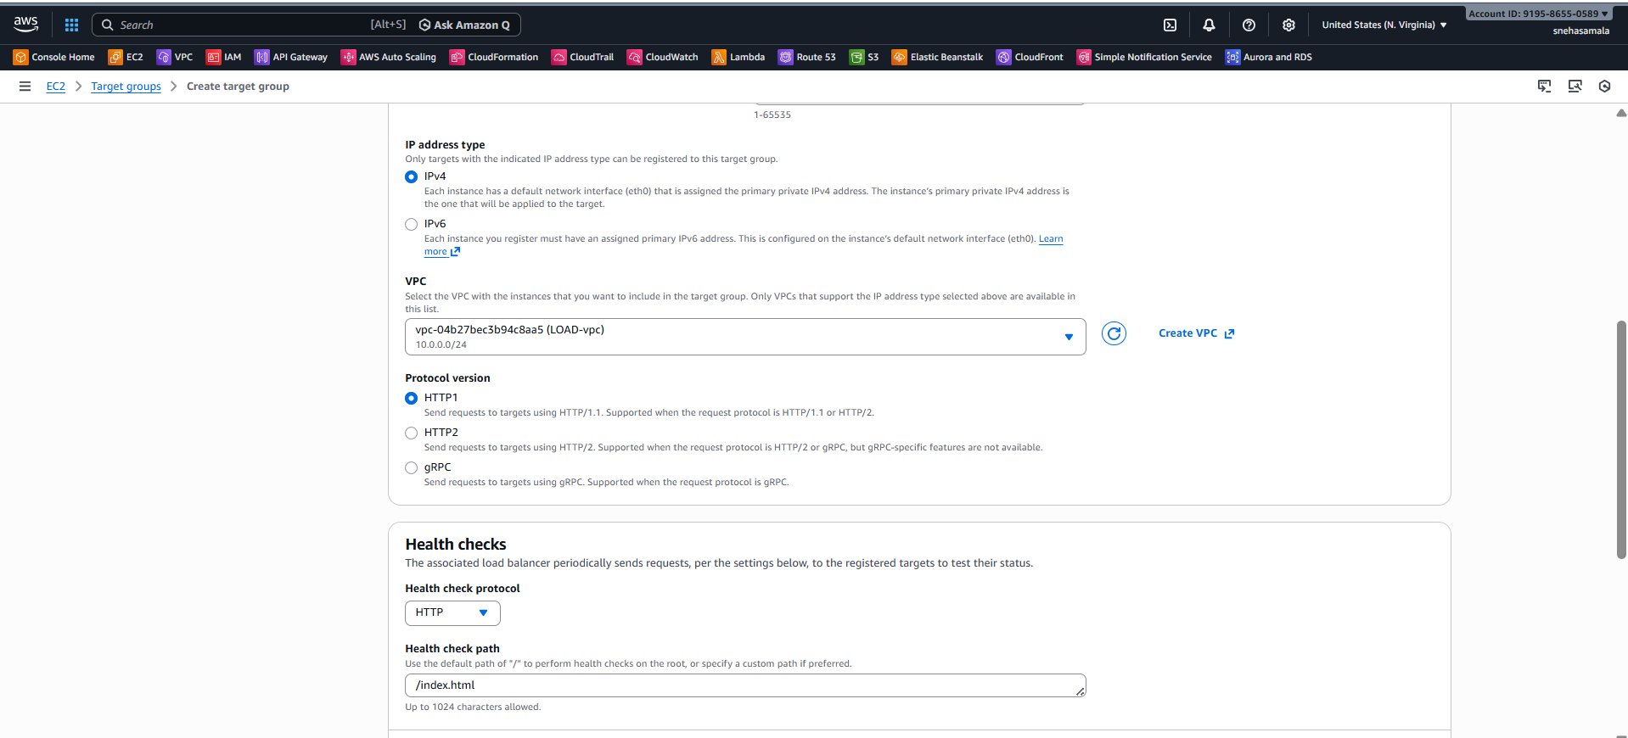
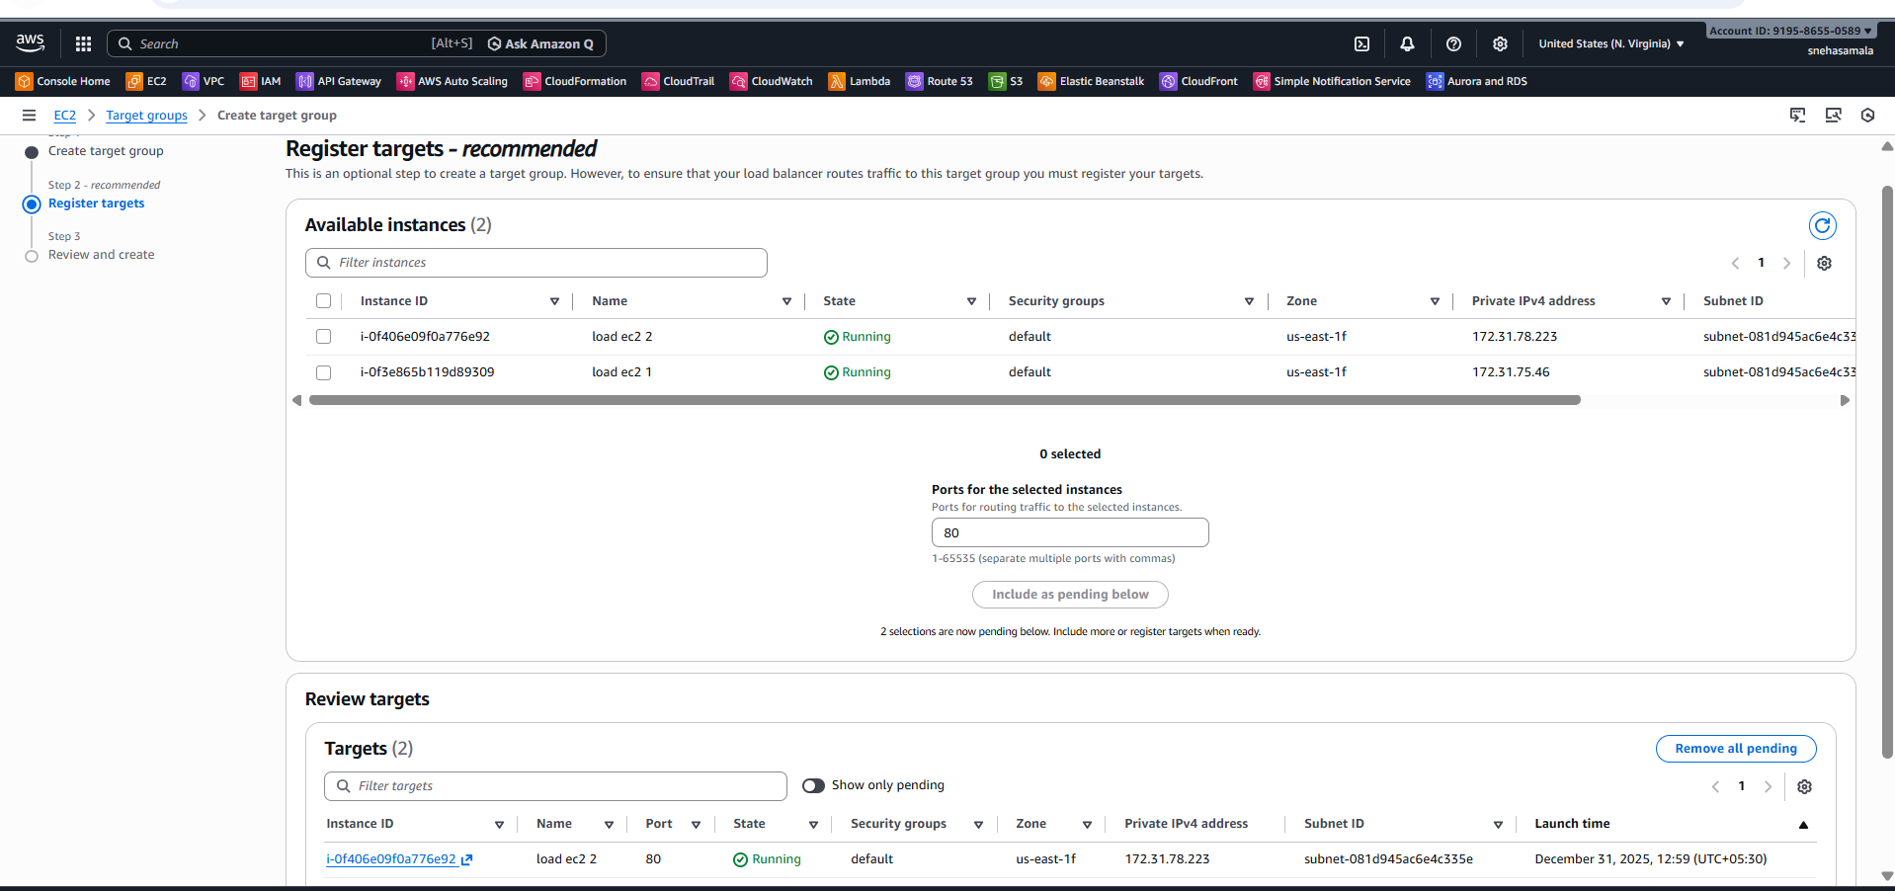
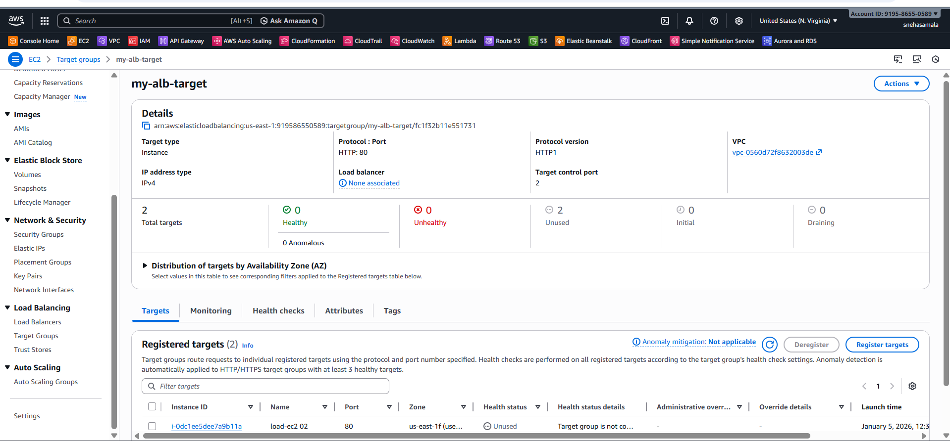

- Create Application Load Balancer
- This creates the actual load balancer that receives user traffic.
Steps:
- Go to EC2 → Load Balancers → Create Load Balancer
- Select Application Load Balancer
- Configure basic settings:

- Name: load-ec2
Scheme:
- Internet-facing (public)
- Internal (private)
- IP type: IPv4
- Select VPC
- Choose at least 2 public subnets (multi-AZ for high availability)
- Assign Security Group:
- Allow inbound:
- HTTP (80)

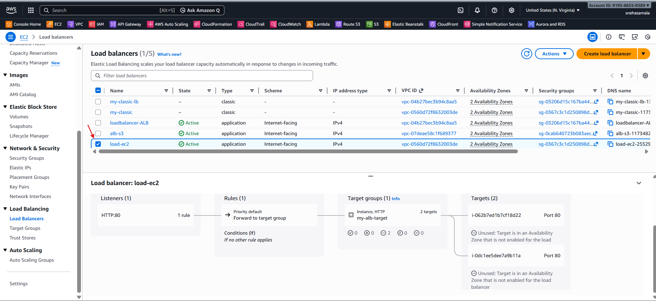
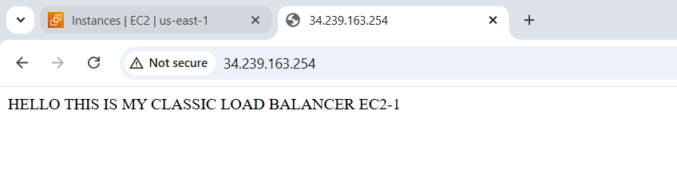
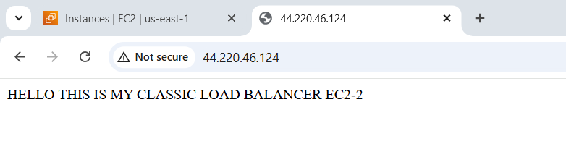

- Configure Network Load balancer.
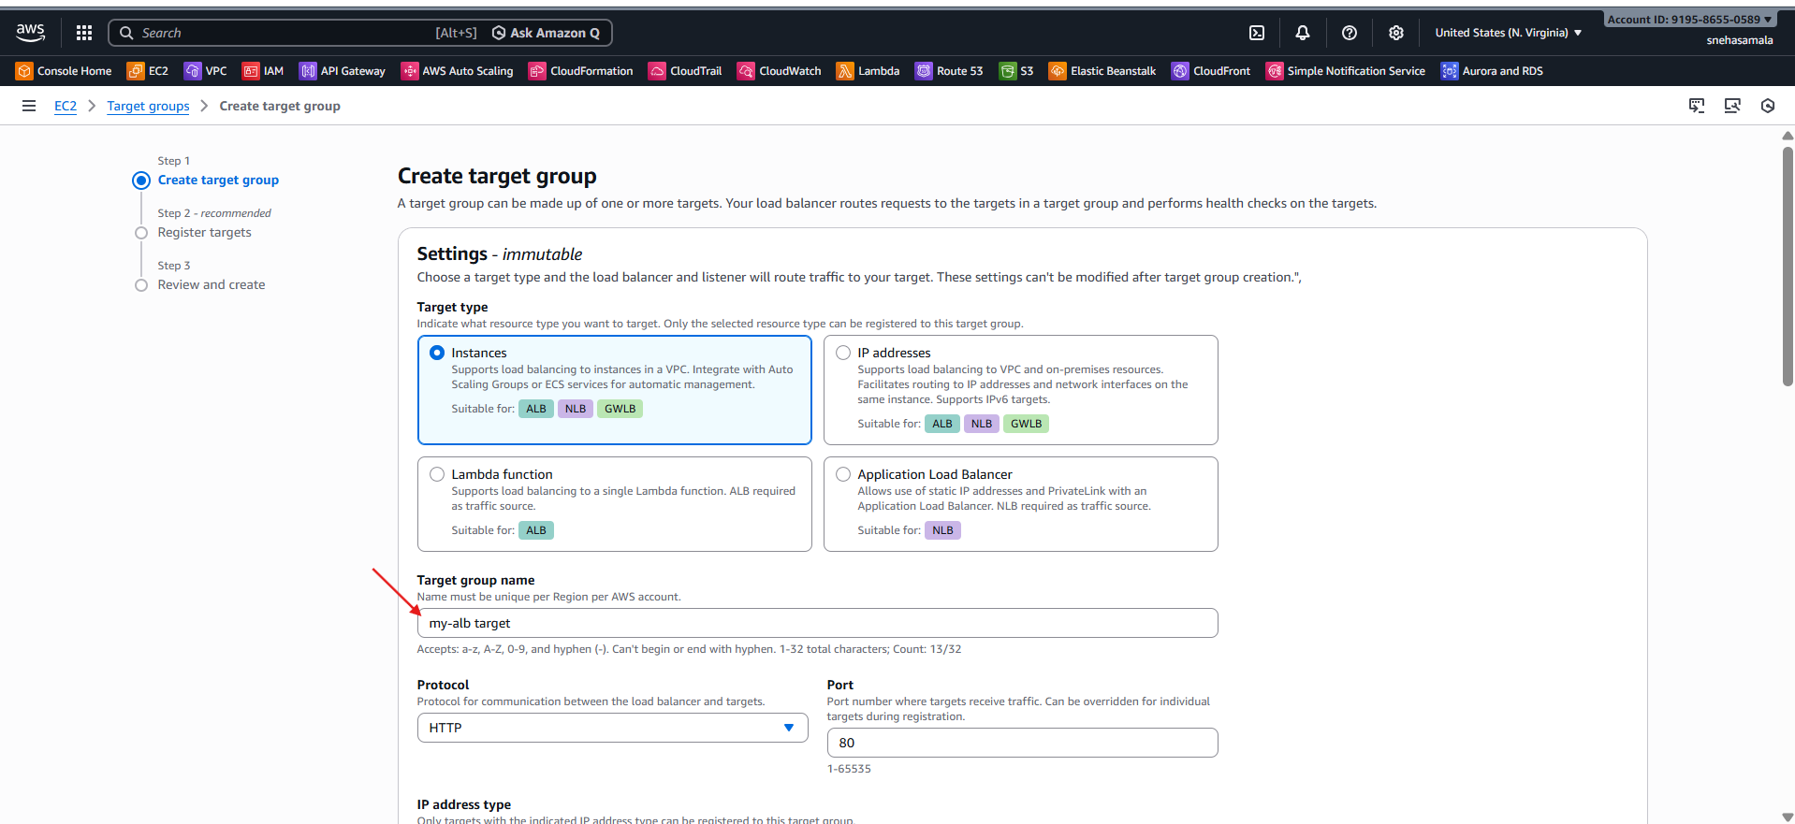
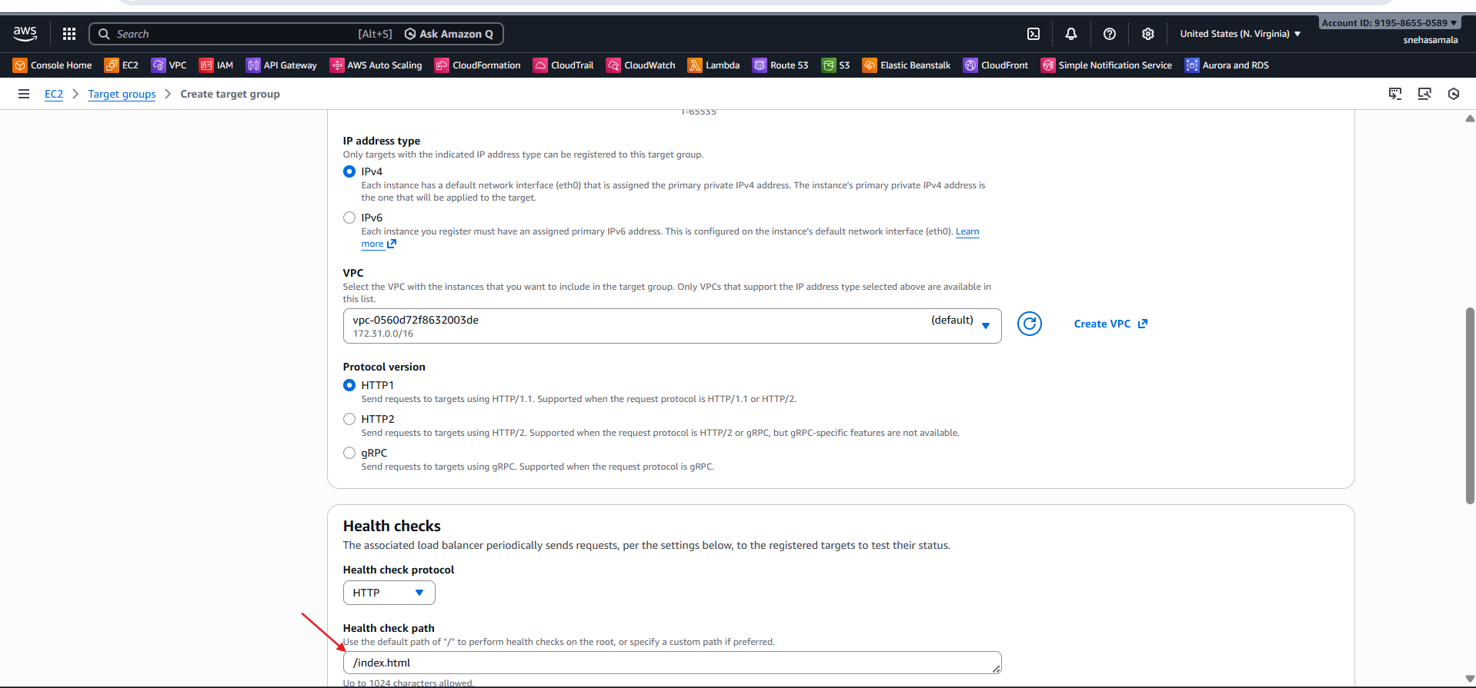
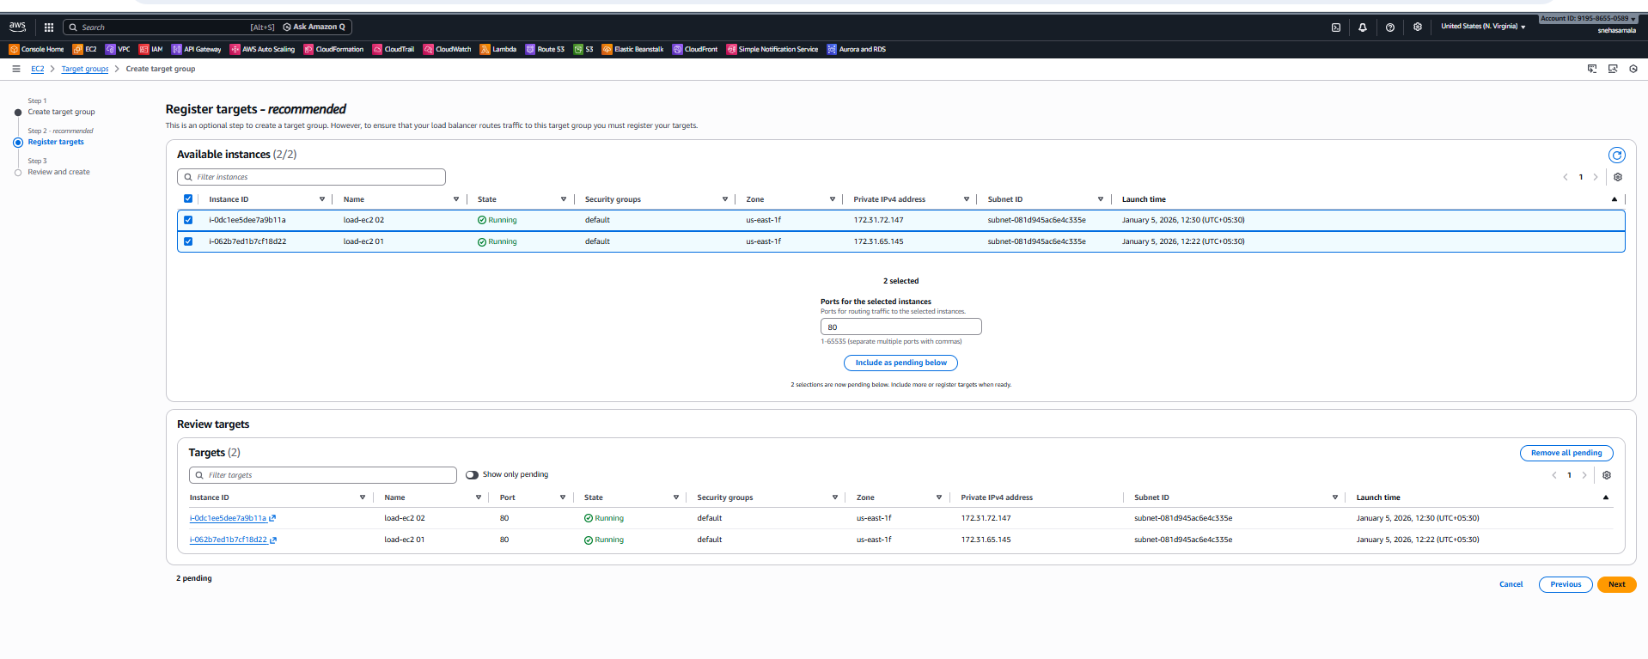
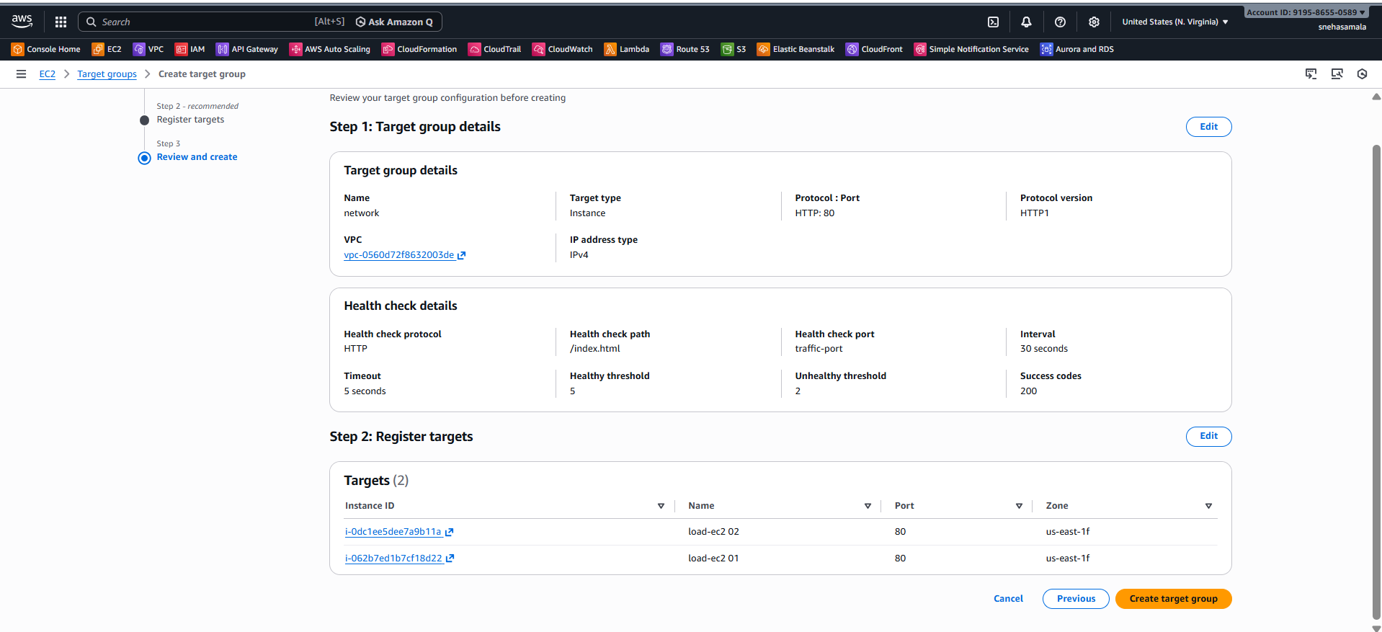
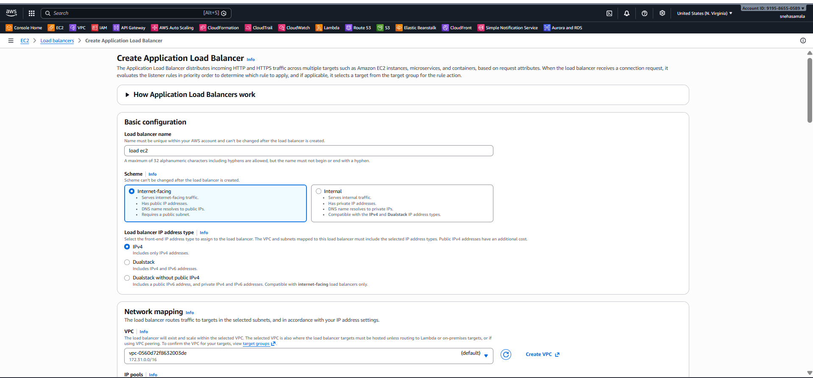
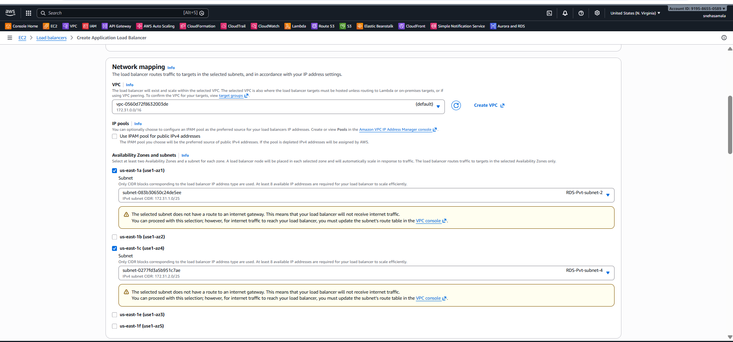
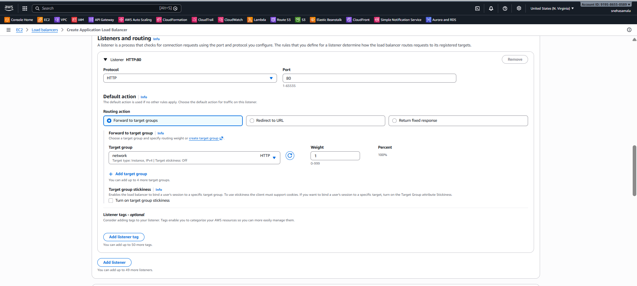
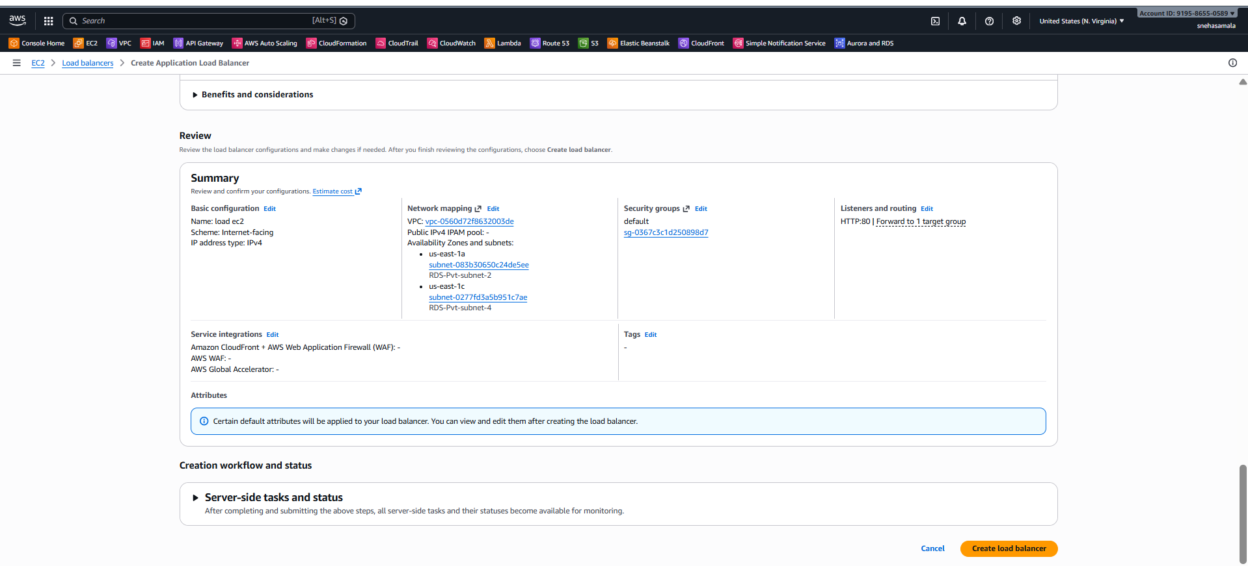
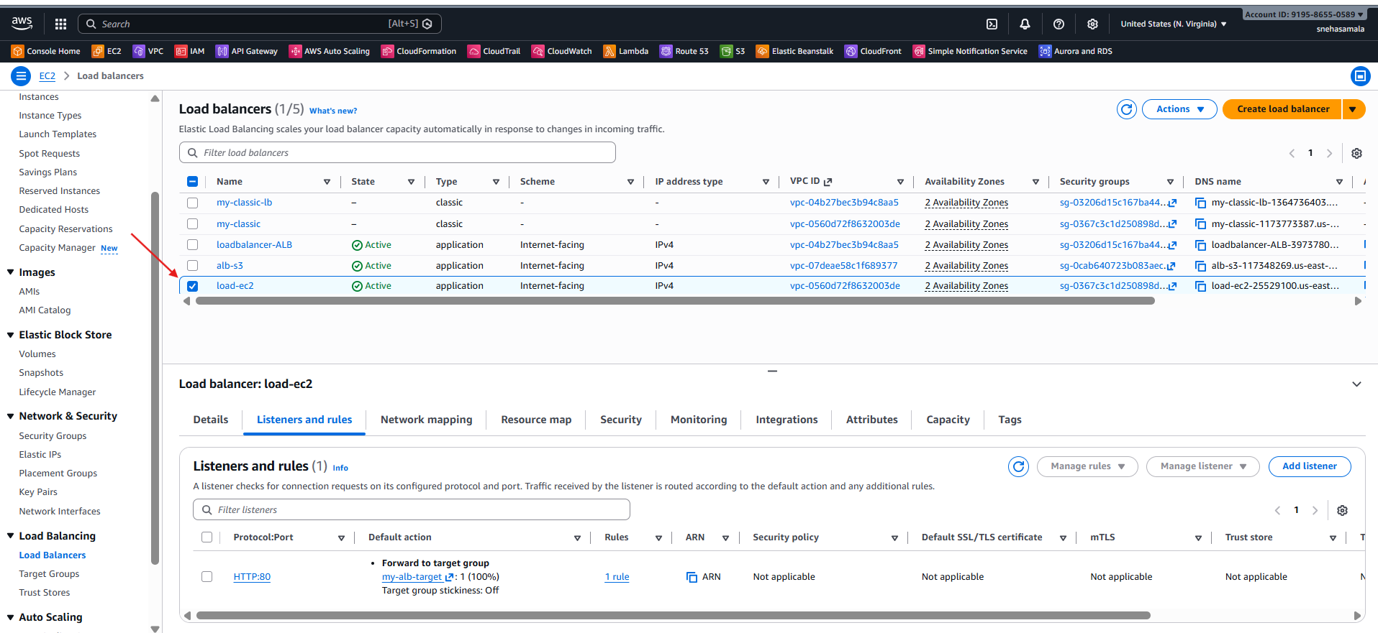

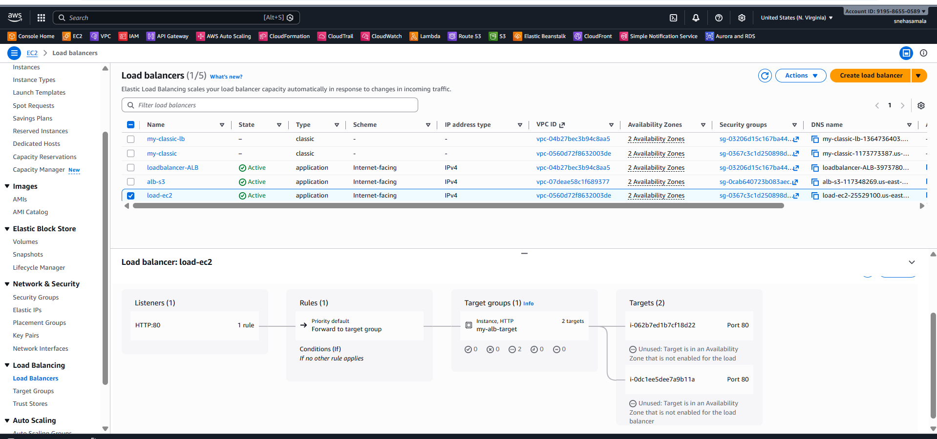

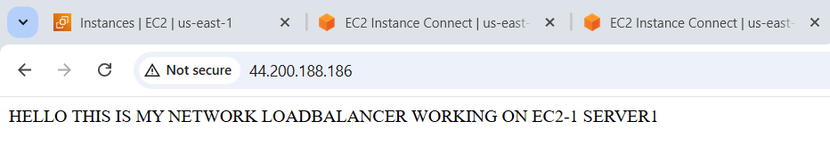
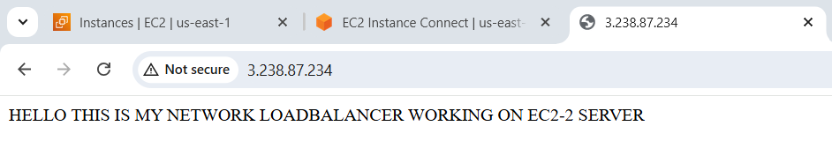

- Attach SSL for application load balancer.
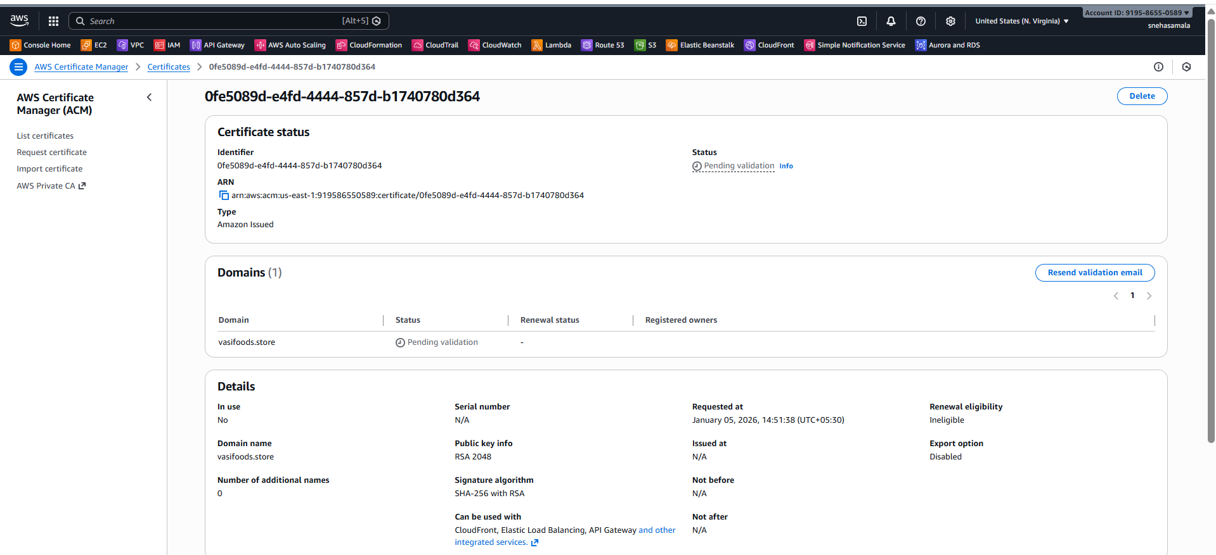

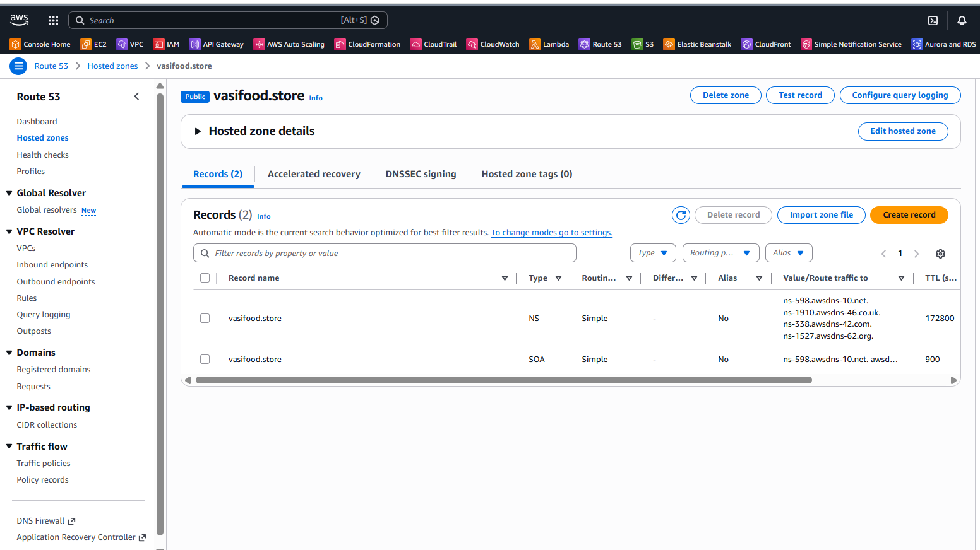
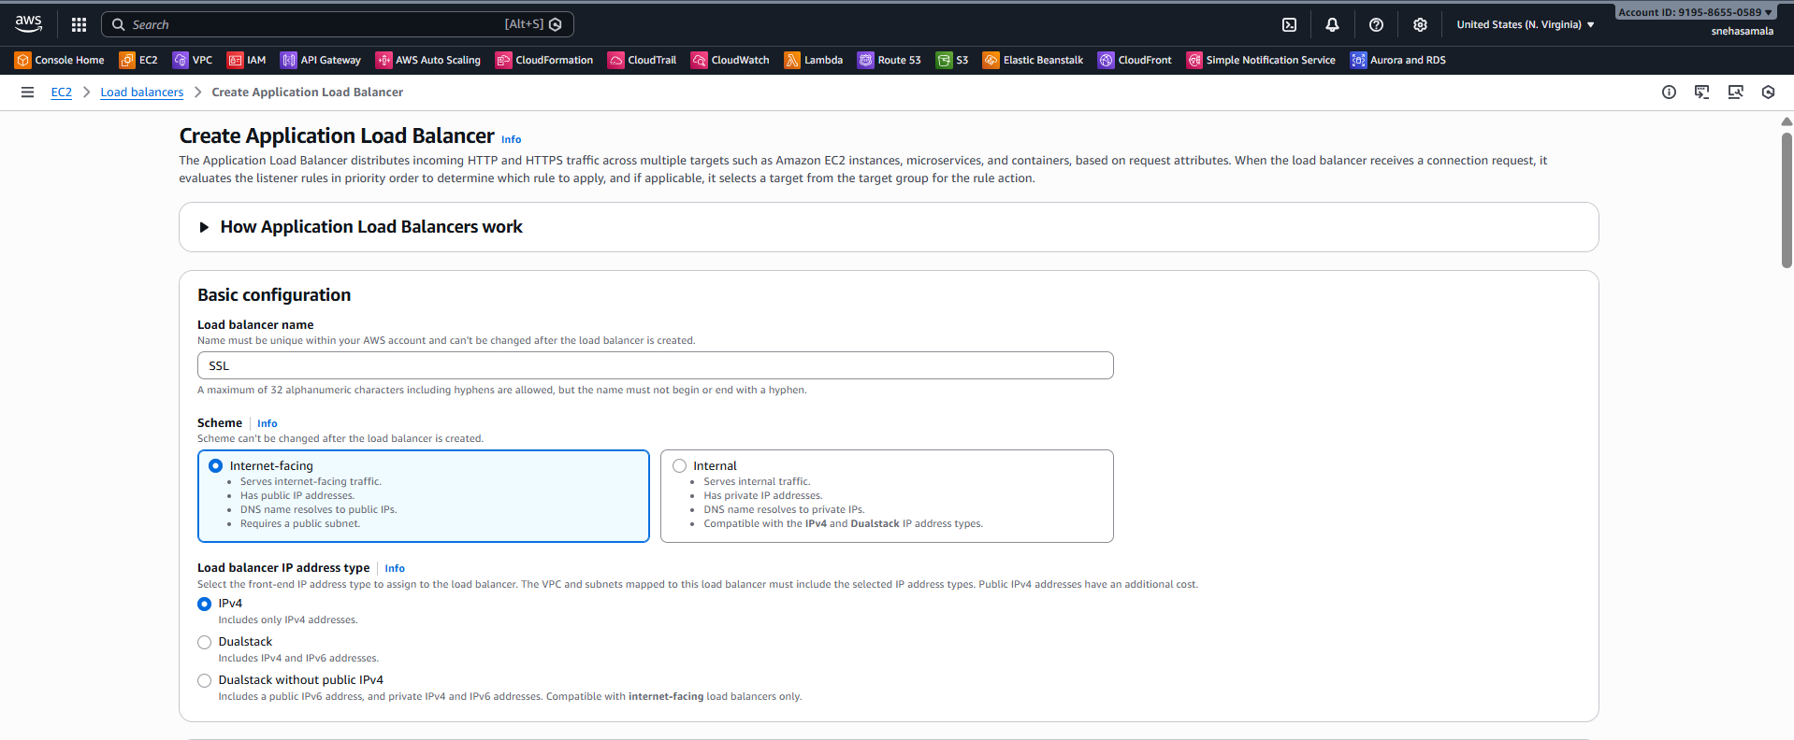

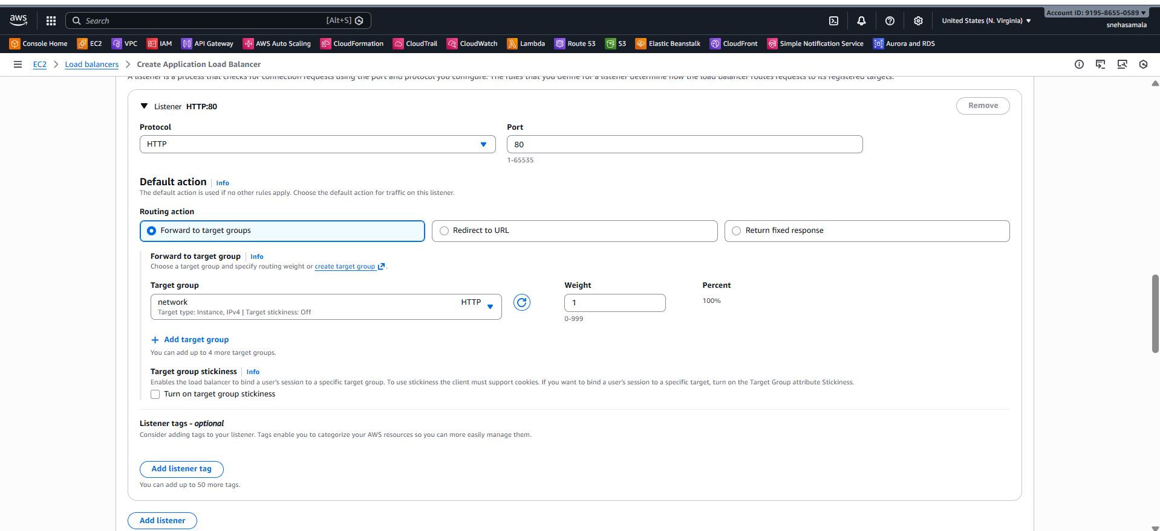
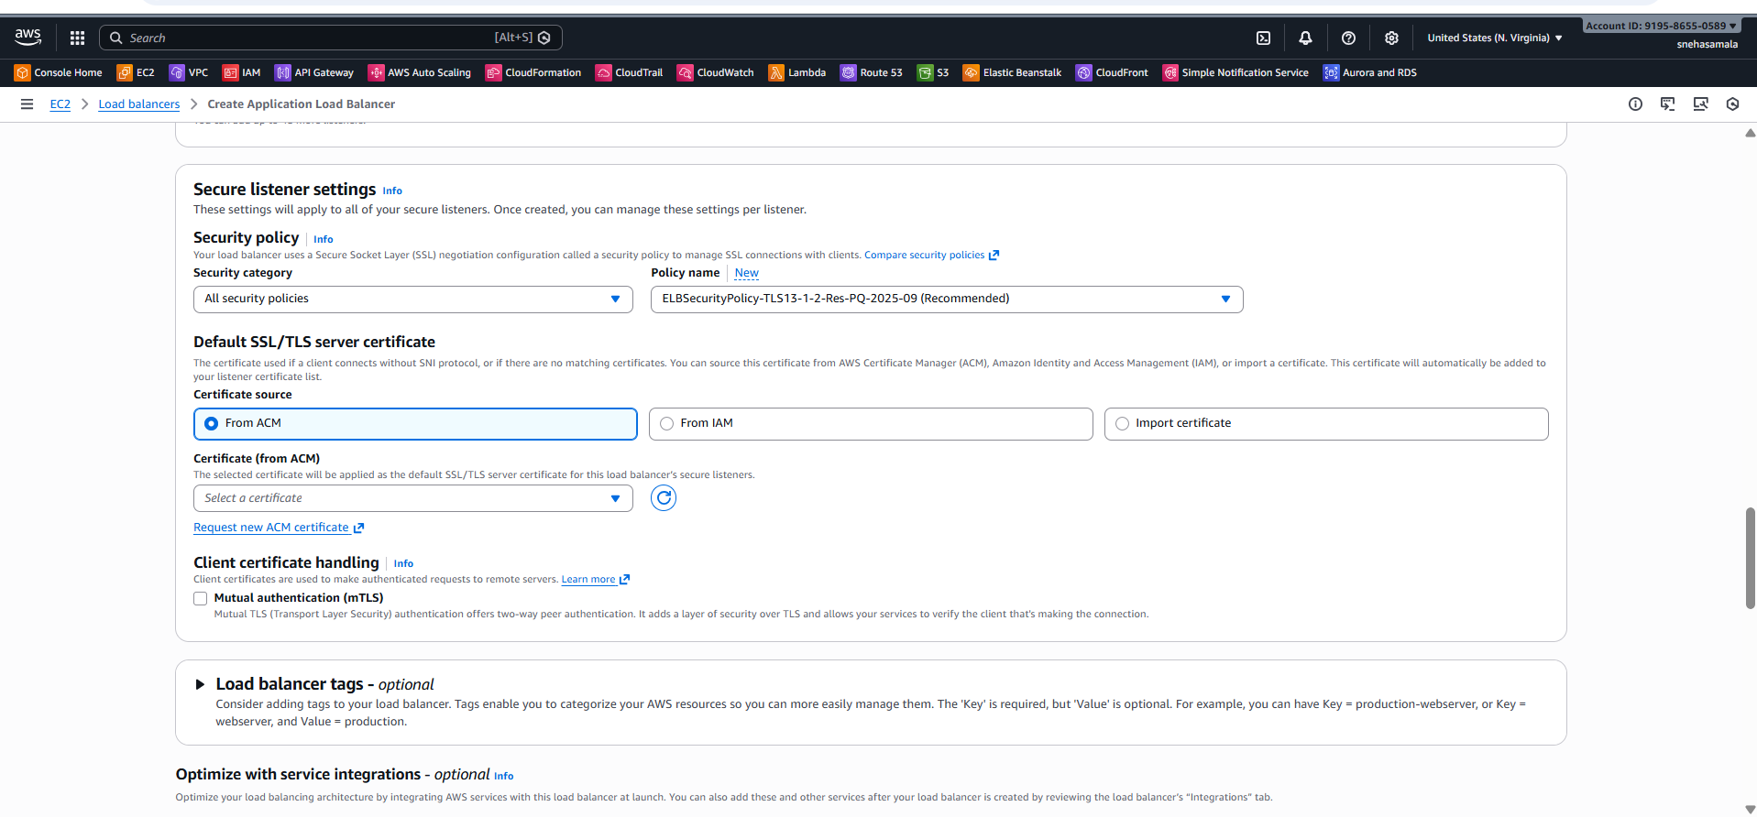

- Map Application load balancer to R53.
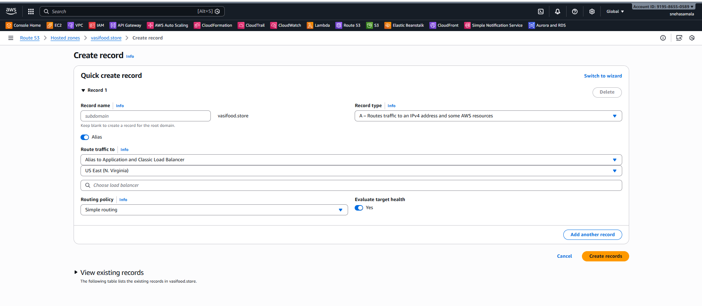
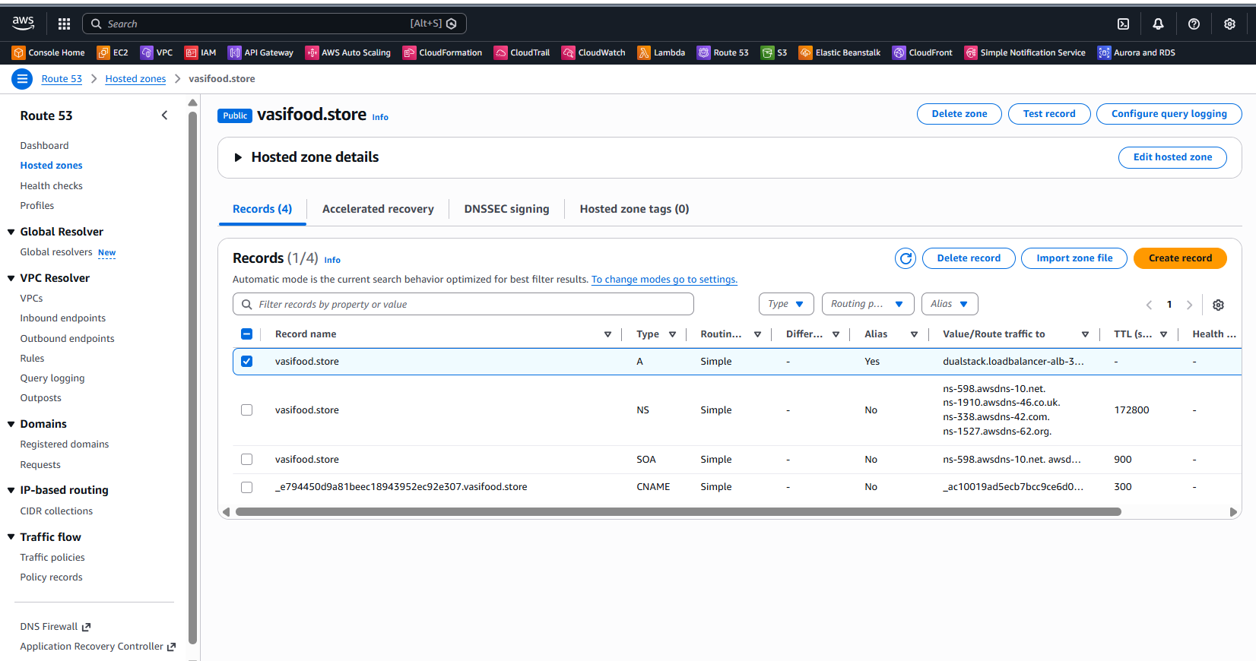
- Push the application load balancer logs to S3.
